4

Super Resolution Image and Other Generative architecture

Deep Learning shines with big data and deeper models. It has millions of parameters that can take even weeks to train. Some real-life scenarios may not have sufficient data, hardware or resources to train bigger network in order to achieve the desired accuracy. Is there any alternative approach or do we need to reinvent the training wheel from scratch all the time?

In this chapter, we will first look at the powerful and widely used training approach in modern deep learning based applications named Transfer Learning through hands-on example with real datasets (MNIST, Cars vs Cats vs Dogs vs Flower, LFW). Also, you will build deep learning based network over large distributed cluster using Apache Spark and BigDL. Then you will combine both Transfer Learning and GAN to generate high resolution realistic images with facial dataset. Finally, you will also understand the way of creating artistic hallucination on images beyond GAN.

We will cover the following topics in this chapter:

* What is Transfer Learning? Its benefits and applications.
* Classifying cars vs dog vs flower with pre-trained VGG model using Keras.
* Training and Deploying Deep Network over large distributed clusters with Apache Spark-Deep Learning Pipeline.
* Identifying handwritten digits through Feature extraction and fine tuning using BigDL.
* High resolution image generation using pre-trained model and SRGAN.
* Generating artistic hallucinated images with Deep Dream and image generation with VAE.

Building a deep learning model from scratch requires sophisticated resource and also it is very time consuming. And hence you don’t always want to build such deep model from scratch to solve your problem at hand. Instead of reinventing the same wheel, you will reuse an already existing model built for similar problem to satisfy your use-case.

Let say you want to build a self-driving car. You have to spend years to build a decent image recognition algorithm from scratch or you can simply take the pre-trained inception model built by Google from huge dataset of ImageNet. A pre-trained model may not reach the desired accuracy level for your application, but it saves huge effort required to re-invent the wheel. And with some fine tuning and tricks your accuracy level will definitely improve.

**Introduction to Transfer Learning**

**Pre-trained models** are not optimized for tackling user specific dataset, but are extremely useful for the task at hand that has similarity with the trained model task.

For example, a popular model InceptionV3 is optimized for classifying images on a broad set of 1000 categories, but our domain might be to classify some dog breeds. A well-known technique used in deep learning that adapts an existing trained model for a similar task to the task at hand is known as **Transfer Learning**.

And this is why transfer learning has gain a lot of popularity among deep learning practitioners and in recent years become the go-to technique in many real-life use cases. It is all about transferring knowledge (or features) among related domain.

**Purpose of Transfer Learning**

The main scenarios for using transfer learning in your deep learning workflow are as follows:

**Smaller dataset-** When you have smaller dataset, building a deep learning model from scratch won’t work well. Transfer learning provides the way to apply a pre-trained model to new classes of data. Let say a pre-trained model built from 1million images of ImageNet data will converge to decent solution (after training on just a fraction of the available smaller training data, e.g. cifar-10) compared to a deep learning model built with smaller dataset from scratch.

**Less Resource-** Deep learning process (such as convolution) requires significant amount of resource and time. Deep Learning process are well suited to run on high graded GPU based machine. But with pre-trained model, you can easily train across a full training set (let say 50000 images) in less than a minute using your laptop/notebook without GPU, since majority of time model is modified in the final layer with simple update of just a classifier or regressor.

**Various approaches of using pre-trained models**

**Feature extractor** – A pre-trained model can be used as a feature extraction mechanism just by simply removing the output layer of the network (that gives the probabilities for being in each of the n classes) and then freezing all the previous layers of the network as a fixed feature extractor for the new data set.

**Using pre-trained Architecture** – Instead of transferring weights of the trained model, we can only use the architecture and initialize our own random weights to our new dataset.

**Partially freezing the network**– Instead of replacing only the final layer and extracting features from all previous layers, sometime we might train our new model partially (i.e. to keep the weights of initial layers of the network frozen while retraining only the higher layers). Choice of the number of frozen layers can be consider as one more hyper-parameter.

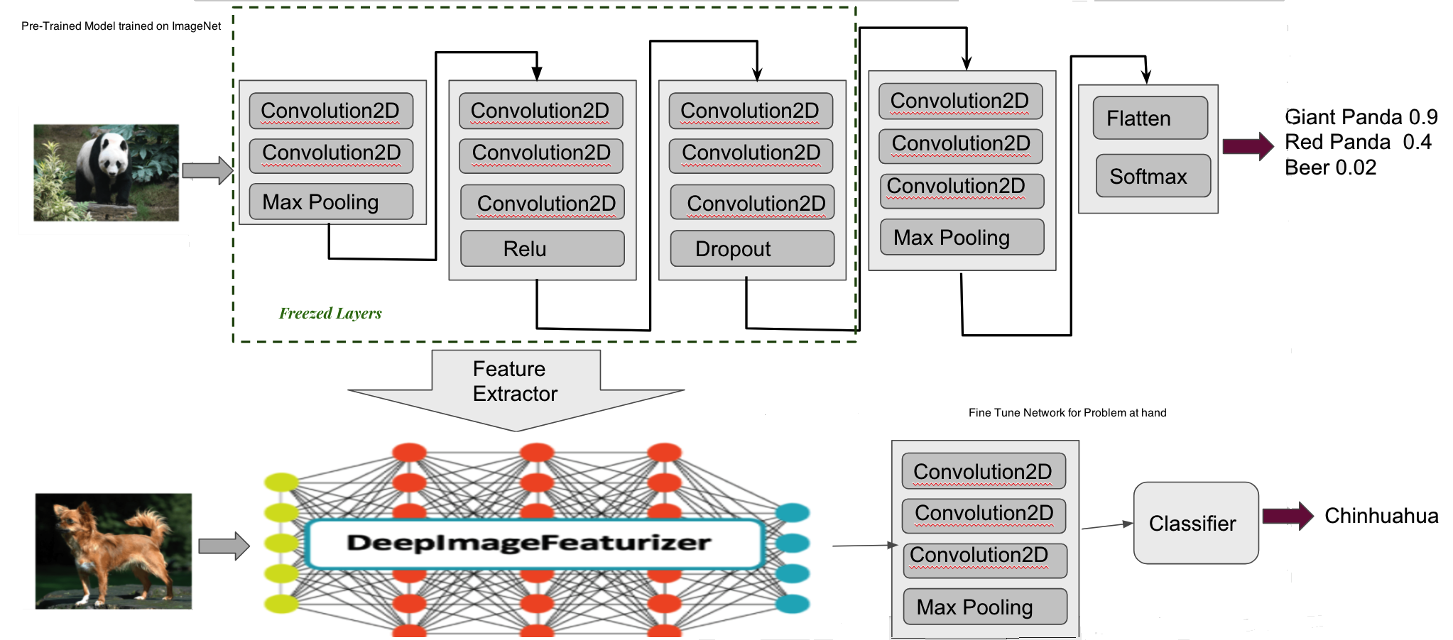

Figure-1: Transfer Learning with pre-trained model

**B08086_04_01.png**

Depending mainly on data size and dataset similarity, you might have to decide on how to proceed with transfer learning. The table below discuss these scenarios:

|  |  |  |
| --- | --- | --- |
|  | **High Data Similarity** | **Low Data Similarity** |
| **Data size Small** | In the scenario of small data size but high data similarity, we will modify only the outputs layers of the pre-trained model and use it as feature extractor. | When both data size as well as data similarity is low, we can freeze initial k layers of the pre-trained network and train only the (n-k) remaining layers again. This will help the top layers to customize to the new dataset and small data size will also get compensated by frozen initial k layers of the network. |
| **Data size Large** | In this scenario, we can use the architecture and initial weights of the pre-trained model. | Although we have a large dataset, but the data is very different compared to one used for training pre-trained model, so using it in this scenario would not be effective. Instead it is better to train the deep network from scratch. |

In case of image recognition transfer learning utilize the pre-trained convolutional layers to extract features about the new input images, that means only a small part of the original model (mainly the dense layers) are re-trained. The rest of the network remain “**frozen**.” In this way, it saves a lot of time and resource by passing the raw images through the frozen part of the network only once, and then never goes through that part of the network again.

## Classifying car vs cat vs dog vs flower using Keras

Let us implement the concept of transfer learning and fine-tuning to identify customizable object categories using a customize dataset consisting of 150 training images and 50 validation images for each category of car, cat, dog and flower. Note that dataset is prepared by taking images from Kaggle cat vs dog (https://www.kaggle.com/c/dogs-vs-cats), Stanford cars (<http://ai.stanford.edu/~jkrause/cars/car_dataset.html)> and Oxford flower dataset (http://www.robots.ox.ac.uk/~vgg/data/flowers).

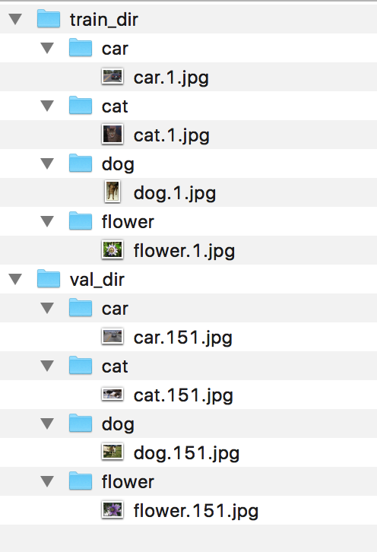

Figure-2: Car vs Cat vs Dog vs Flower dataset structure

**B08086_04_02.png**

We need to perform some preprocessing using the pre-processing function and apply various data augmentation transformation through rotation, shifting, shearing, zooming, and flipping parameters.

train_datagen = ImageDataGenerator(  
 preprocessing_function=preprocess_input,  
 rotation_range=30,  
 width_shift_range=0.2,  
 height_shift_range=0.2,  
 shear_range=0.2,  
 zoom_range=0.2,  
 horizontal_flip=True  
)

test_datagen = ImageDataGenerator(  
 preprocessing_function=preprocess_input,  
 rotation_range=30,  
 width_shift_range=0.2,  
 height_shift_range=0.2,  
 shear_range=0.2,  
 zoom_range=0.2,  
 horizontal_flip=True  
)

train_generator = train_datagen.flow_from_directory(  
 args.train_dir,  
 target_size=(IM_WIDTH, IM_HEIGHT),  
 batch_size=batch_size,  
)

validation_generator = test_datagen.flow_from_directory(  
 args.val_dir,  
 target_size=(IM_WIDTH, IM_HEIGHT),  
 batch_size=batch_size,  
)

Next, we need to load the InceptionV3 model from the keras.applications module. The flag include_top=False is used to leave out the weights of the last fully connected layer.

base_model = InceptionV3(weights='imagenet', include_top=False)

Initialize a new last layer by adding fully-connected Dense layer of size 1024, followed by a softmax function on the output to squeeze the values between [0,1].

def addNewLastLayer(base_model, nb_classes):  
 x = base_model.output  
 x = GlobalAveragePooling2D()(x)  
 x = Dense(FC_SIZE, activation='relu')(x)   
 predictions = Dense(nb_classes, activation='softmax')(x)   
 model = Model(input=base_model.input, output=predictions)  
 return model

Once the last layer of the network is stabilized (transfer learning), we can move onto retraining more layers (fine-tuning).

Utility method to freeze all layers and compile the model.

def setupTransferLearn(model, base_model):  
 for layer in base_model.layers:  
 layer.trainable = False  
 model.compile(optimizer='rmsprop',   
 loss='categorical_crossentropy',   
 metrics=['accuracy'])

Another utility method to freeze the bottom of top 2 inception blocks in the inceptionv3 architecture and retrain the remaining top.

def setupFineTune(model):  
 for layer in model.layers[:NB_IV3_LAYERS_TO_FREEZE]:  
 layer.trainable = False  
 for layer in model.layers[NB_IV3_LAYERS_TO_FREEZE:]:  
 layer.trainable = True  
 model.compile(optimizer=SGD(lr=**0.0001**, momentum=0.9), loss='categorical_crossentropy')

Now we’re all ready for training using fit_generator method and finally save our model.

history = model.fit_generator(  
 train_generator,  
 samples_per_epoch=nb_train_samples,  
 nb_epoch=nb_epoch,  
 validation_data=validation_generator,  
 nb_val_samples=nb_val_samples,  
 class_weight='auto')

model.save(args.output_model_file)

Run the following command for training and fine tuning:

python training-fine-tune.py --train_dir <path to training images> --val_dir <path to validation images>

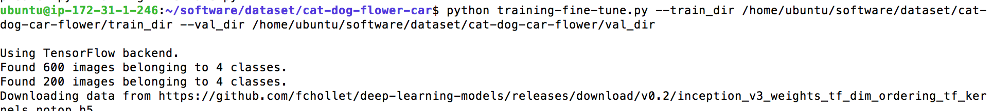

**B08086_04_03.png**

Even with such a small dataset size, we are able to achieve an accuracy of 98.5% on the validation set by utilizing the power of pre-trained model and transfer learning.

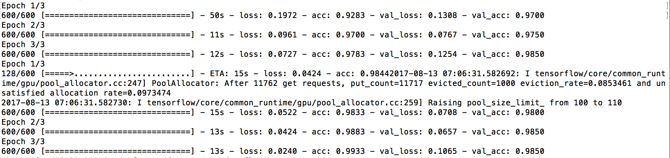

**B08086_04_04.png**

Voila we can now use the saved model to predict images (either from local file system or from url) with test data.

python predict.py --image_url https://goo.gl/DCbuq8 --model inceptionv3-ft.model

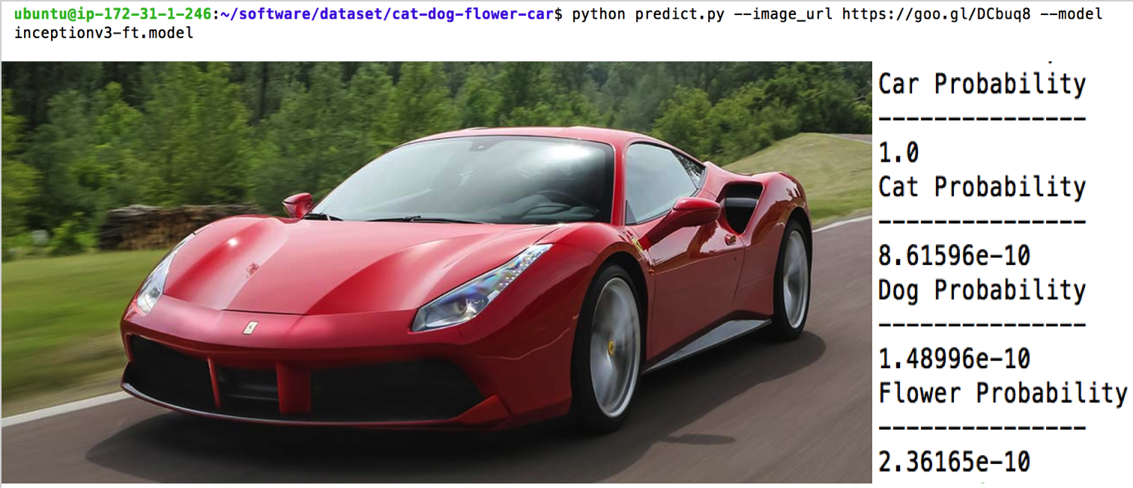

**B08086_04_05.png**

## Large Scale Deep Learning with Apache Spark

Deep learning is resource hungry and computationally intensive process and you get better result with more data and bigger network, but its speed gets impacted by the size of the datasets as well. And in practice, deep learning requires experimenting with different values for training parameters known as hyper-parameter tuning, where you have to run your deep networks on large dataset iteratively or many times and speed do matter. Some common ways to tackle this problem is to use faster hardware (usually GPUs), optimized code (with proper production ready framework) and scaling out over distributed cluster to achieve some form of parallelism.

**Data parallelism** is a concept of sharding large datasets into multiple chunks of data and then process chunk over neural network running on separate nodes of distributed cluster.

**Apache Spark** is a fast, general-purpose, fault-tolerant framework for interactive and iterative computations on large, distributed datasets by doing do in-memory processing of RDDs or DataFrames instead of saving data to hard disks. It supports a wide variety of data sources as well as storage layers. It provides unified data access to combine different data formats, streaming data and defining complex operations using high-level, composable operators.

Today Spark is the superpower of big data processing and makes big data accessible to everyone. But Spark or its core modules alone are not capable of training or running deep networks over the clusters. In the next few sections we will develop deep learning applications over Apache Spark cluster with optimized libraries.

Please note that for the coding purpose, we will not cover the distributed spark cluster setup, instead use Apache Spark standalone mode. More information about Spark cluster mode can be found at:

(<https://spark.apache.org/docs/latest/cluster-overview.html)> .

## Running pre-trained model using Spark Deep Learning

**Deep Learning Pipelines**, is an open-source library that leverage the power of Apache Spark cluster to easily integrate scalable deep learning into machine learning workflows. It is built on top of Apache Spark’s ML Pipelines for training, and uses Spark DataFrames and SQL for deploying models. It provides high-level APIs for running transfer learning in a distributed manner by integrating pre-trained model as transformer in Spark ML Pipeline.

Deep Learning Pipelines makes transfer learning easier with the concept of a **Featurizer**. The Featurizer (or **DeepImageFeaturizer** in case of image operation) automatically remove the last layer of a pre-trained neural network model and uses all the previous layers output as features for the classification algorithm (e.g. Logistic Regression) specific to new problem domain.

Let us implement deep learning pipeline for predicting sample images of flower dataset (http://download.tensorflow.org/example_images/flower_photos.tgz) with pre-trained model over spark cluster.

First start the pyspark with the deep learning pipeline package.

pyspark --master local[*] --packages databricks:spark-deep-learning:0.1.0-spark2.1-s_2.11

Note: If you get the error (“No module named sparkdl”) while starting the pySpark with deep learning, please check the github page for workaround:

<https://github.com/databricks/spark-deep-learning/issues/18>

First read the images and randomly split it into train, test set.

img_dir= “path to base image directory”

roses_df = readImages(img_dir + “/roses”).withColumn("label", lit(1))

daisy_df = readImages(img_dir + "/daisy").withColumn("label", lit(0))

roses_train, roses_test = roses_df.randomSplit([0.6, 0.4])

daisy_train, daisy_test = daisy_df.randomSplit([0.6, 0.4])

train_df = roses_train.unionAll(daisy_train)

Then create a pipeline with DeepImageFeaturizer using InceptionV3 model.

featurizer = DeepImageFeaturizer(inputCol="image", outputCol="features", modelName="InceptionV3")

lr = LogisticRegression(maxIter=20, regParam=0.05, elasticNetParam=0.3, labelCol="label")

p = Pipeline(stages=[featurizer, lr])

Now fit the images with existing pre-trained model,where train_images_df is a dataset of images and labels.

p_model = p.fit(train_df)

Finally, we will evaluate the accuracy.

tested_df = p_model.transform(test_df)

evaluator = MulticlassClassificationEvaluator(metricName="accuracy")

print("Test set accuracy = " + str(evaluator.evaluate(tested_df.select("prediction", "label"))))



**B08086_04_06.png**

In addition to DeepImageFeaturizer, we can also utilize the preexisting model just to do prediction, without any retraining or fine tuning using DeepImagePredictor.

sample_img_dir=<path to your image>

image_df = readImages(sample_img_dir)

predictor = DeepImagePredictor(inputCol="image", outputCol="predicted_labels", modelName="InceptionV3", decodePredictions=True, topK=10)

predictions_df = predictor.transform(image_df)

predictions_df.select("filePath", "predicted_labels”).show(10,False)

The input image and its top 5 predictions shown below:

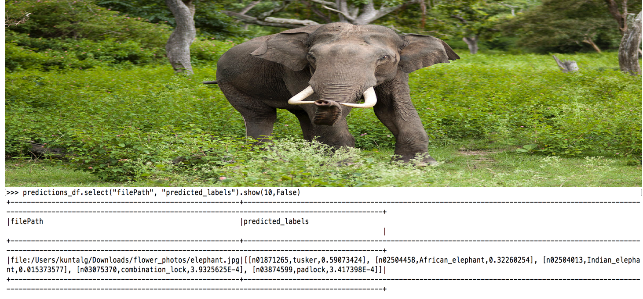

**B08086_04_07.png**

In addition to using the built-in pre-trained models, deep learning pipeline allows users to plug in [Keras models](https://keras.io/models/about-keras-models/) or TensorFlow Graphs in a Spark prediction pipeline. This really turns any single-node deep models running on single-node machine into one that can be trained and deployed in a distributed fashion, on a large amount of data.

First, we will load keras built-in InceptionV3 model and save it in file.

model = InceptionV3(weights="imagenet")

model.save('model-full.h5')

During Prediction phase, we will simply load the model and pass images through it to get desired prediction.

def loadAndPreprocessKerasInceptionV3(uri):

# this is a typical way to load and prep images in keras

image = img_to_array(load_img(uri, target_size=(299, 299)))

image = np.expand_dims(image, axis=0)

return preprocess_input(image)

transformer = KerasImageFileTransformer(inputCol="uri",

outputCol="predictions",

modelFile="model-full.h5",

imageLoader=loadAndPreprocessKerasInceptionV3,

outputMode="vector")

dirpath=<path to mix-img>

files = [os.path.abspath(os.path.join(dirpath, f)) for f in os.listdir(dirpath) if f.endswith('.jpg')]

uri_df = sqlContext.createDataFrame(files, StringType()).toDF("uri")

final_df = transformer.transform(uri_df)

final_df.select("uri", "predictions”).show()

Deep Learning Pipeline is really fast way of doing transfer learning over distributed spark cluster. But you must have notice that Featurizer only allow us to change the final layer of the pre-trained model. But in some scenario, you might have to modify more than one layer of the pre-trained network to get desired result and Deep Learning Pipeline doesn’t provide this full capability.

## Handwritten Digit Recognition at large scale using BigDL

BigDL is an open-source distributed high performance deep learning library that can run directly on top of Apache Spark clusters. Its high performance is achieved by combing **Intel® Math Kernel Library** (MKL) along with Multithreaded programming in each Spark task. BigDL provides Keras style (both Sequential and Function) high-level APIs to build deep learning application and scale out to perform analytics at large scale. The main purpose of using BigDL are:

* Running Deep Learning model at large scale and analyzing massive amount of data residing in Spark or **Hadoop** Cluster (in say **Hive**, **HDFS** or **Hbase**).
* Adding Deep Learning functionality (both training and prediction) to your big data workflow

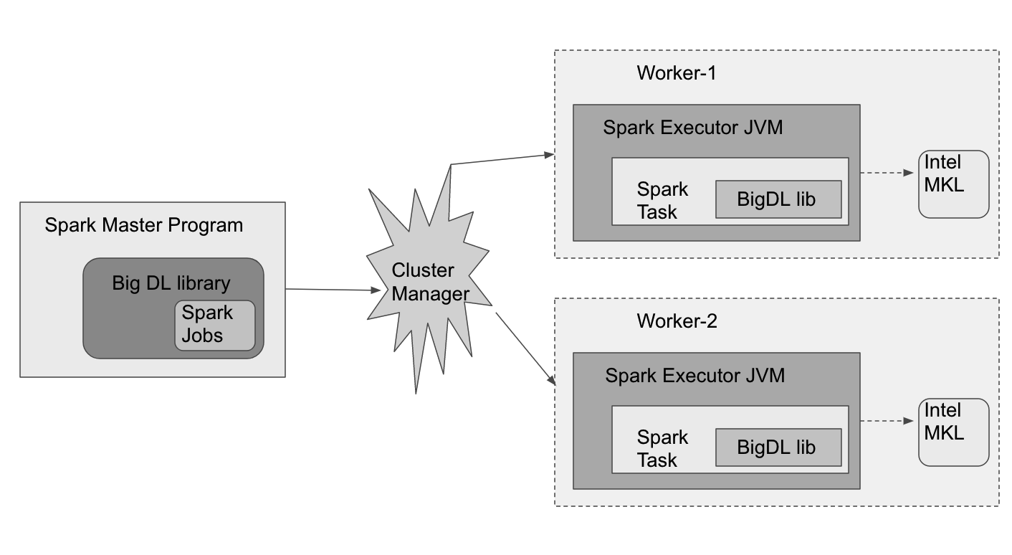

Figure-3: BigDL execution over Spark cluster

**B08086_04_08.png**

As you can see from the figure that BigDL driver program is first launched in the Spark master node of the cluster. Then with the help of cluster manager and the driver program, Spark tasks are distributed across the Spark executors on the worker nodes. And BigDL interacts with Intel MKL to enables faster execution of those tasks.

Let us implement a deep neural network at large scale for identifying hand-written digit with MNIST dataset. First we will prepare training and validation samples

mnist_path = "datasets/mnist"

(train_data, test_data) = get_mnist(sc, mnist_path)

print train_data.count()

print test_data.count()

Then we will create the **LeNet** architecture consisting of two sets of convolutional, activation, and pooling layers, followed by a fully-connected layer, activation, another fully-connected, and finally a softmax classifier. LeNet is small, yet powerful enough to provide interesting results.

def build_model(class_num):

model = Sequential()

model.add(Reshape([1, 28, 28]))

model.add(SpatialConvolution(1, 6, 5, 5).set_name('conv1'))

model.add(Tanh())

model.add(SpatialMaxPooling(2, 2, 2, 2).set_name('pool1'))

model.add(Tanh())

model.add(SpatialConvolution(6, 12, 5, 5).set_name('conv2'))

model.add(SpatialMaxPooling(2, 2, 2, 2).set_name('pool2'))

model.add(Reshape([12 * 4 * 4]))

model.add(Linear(12 * 4 * 4, 100).set_name('fc1'))

model.add(Tanh())

model.add(Linear(100, class_num).set_name('score'))

model.add(LogSoftMax())

return model

lenet_model = build_model(10)

Now we will configure an Optimizer and set the validation logic.

optimizer = Optimizer(

model=lenet_model,

training_rdd=train_data,

criterion=ClassNLLCriterion(),

optim_method=SGD(learningrate=0.4, learningrate_decay=0.0002),

end_trigger=MaxEpoch(20),

batch_size=2048)

optimizer.set_validation(

batch_size=2048,

val_rdd=test_data,

trigger=EveryEpoch(),

val_method=[Top1Accuracy()]

)

trained_model = optimizer.optimize()

Then we will take a few test samples, and make prediction by checking both the predicted labels and ground truth labels

predictions = trained_model.predict(test_data)

Finally, we would train the LeNet model in spark cluster using spark-submit command. Download the BigDL distribution (https://bigdl-project.github.io/master/#release-download/) based on your apache spark version and then execute the file (run.sh) provided with the code to submit the job in the spark cluster.

SPARK_HOME= <path to Spark>

BigDL_HOME= <path to BigDL>

PYTHON_API_ZIP_PATH=${BigDL_HOME}/bigdl-python-<version>.zip

BigDL_JAR_PATH=${BigDL_HOME}/bigdl-SPARK-<version>.jar

export PYTHONPATH=${PYTHON_API_ZIP_PATH}:${BigDL_HOME}/conf/spark-bigdl.conf:$PYTHONPATH

${SPARK_HOME}/bin/spark-submit \

--master <local or spark master url>\

--driver-cores 5 \

--driver-memory 5g \

--total-executor-cores 16 \

--executor-cores 8 \

--executor-memory 10g \

--py-files ${PYTHON_API_ZIP_PATH},${BigDL_HOME}/BigDL-MNIST.py\

--properties-file ${BigDL_HOME}/conf/spark-bigdl.conf \

--jars ${BigDL_JAR_PATH} \

--conf spark.driver.extraClassPath=${BigDL_JAR_PATH} \

--conf spark.executor.extraClassPath=bigdl-SPARK<version>.jar \

${BigDL_HOME}/BigDL-MNIST.py

More information regarding spark-submit can be found at:

(https://spark.apache.org/docs/latest/submitting-applications.html)

Once you have submitted the job, you can track the progress on the Spark master application page as shown below:

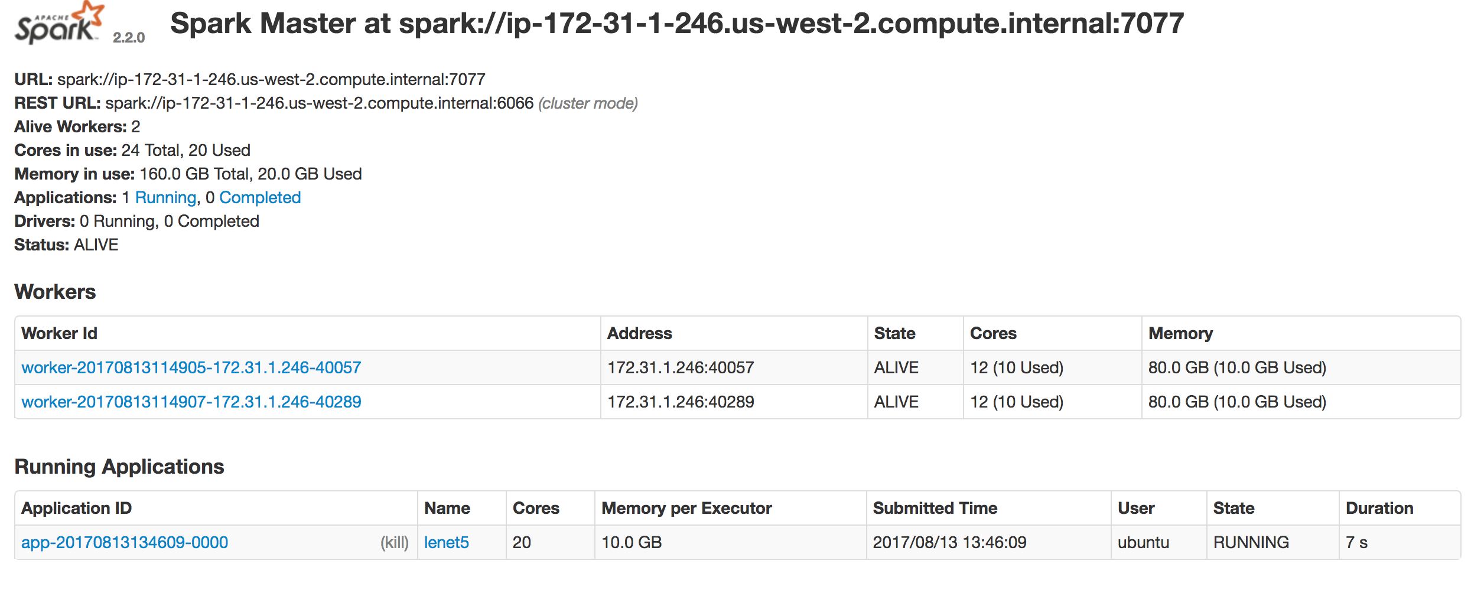

Figure-4: BigDL job of lenet5 model running on Apache Spark Cluster

**B08086_04_09.png**

After the job has successfully finished, you can search the logs of the spark workers to verify the accuracy of your model similar to the one shown below.

INFO DistriOptimizer$:536 - Top1Accuracy is Accuracy(correct: 9568, count: 10000, accuracy: 0.9568)

## High resolution image generation using SRGAN

## Super Resolution generative network or SRGAN excels in generating high resolution image from its low-resolution counterpart. During training phase, the high-resolution image is transformed to low resolution image by applying Gaussian filter to high resolution image followed by down-sampling operation.

## Let us define some notation before diving into the network architecture.

ILR: low resolution image having size width(W) x height(H) x color channels(C).

IHR: high resolution image having size rW × rH × C.

ISR: super resolution image having size rW × rH × C

r: down sampling factor.

GθG: Generator Network

DθD: Discriminator Network

To achieve the goal of estimating high resolution input image from its corresponding low resolution counterpart, the generator network is trained as a feed-forward convolution neural network GθG parametrized by θG where θG is represented by weights (W1:L) and biases (b1:L) of the L-layer of the deep network and is obtained by optimizing super resolution specific loss function. For training images having high resolution I  , n = 1; : : : ;N  along with its corresponding low resolution I  , n = 1; : : : ;N , we can solve for θG, as shown below.

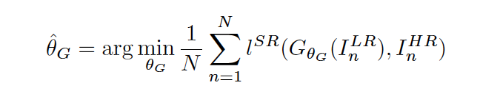

**B08086_04_10.png**

**Note**: The formulation of the perceptual loss function lSR is critical for the performance of the generator network. In general, perceptual loss is commonly modelled based on Mean Square Error (MSE), but to avoid unsatisfying solutions with overly smooth textures, a new content loss based on the ReLU activation layers of the pre-trained 19 layer VGG network is formulated.

The **perceptual loss** is the weighted combination of several loss functions that map important characteristics of super resolution image ass shown below.

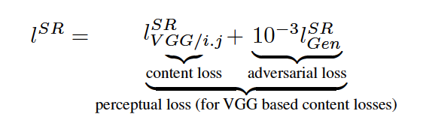

**B08086_04_11.png**

**Content Loss:**the VGG based content loss is defined as the euclidean distance between the feature representations of a reconstructed image GθG (ILR) and the corresponding high-resolution image IHR. Here ϕi;j indicate the feature map obtained by the jth convolution (after activation) before the ith max-pooling layer within the VGG19 network. And Wi;j , Hi;j describe the dimensions of the respective feature maps within the VGG network

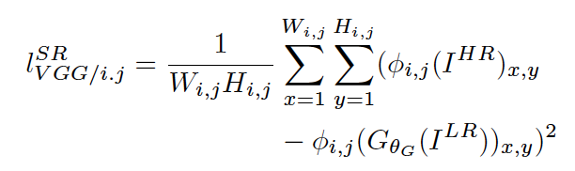

**B08086_04_12.png**

**Adversarial Loss:**The generative loss is based on the probabilities of the discriminator DθD(GθG(ILR)) over all training images and encourages the network to favor solutions residing on the manifold of natural images, in order to fool the discriminator network.

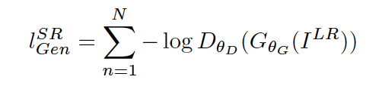

**B08086_04_13.png**

Similar to the concept of adversarial network, the general idea behind the SRGAN approach is to train a generator G with the goal of fooling a discriminator D that is trained to distinguish super-resolution images from real images.

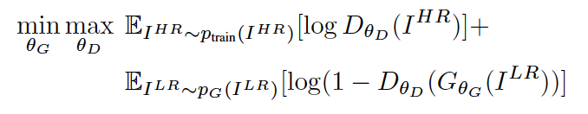

**B08086_04_14.png**

Based on this approach the generator learns to create solutions that are highly similar to real images and thus hard to classify by discriminator D. And this encourages perceptually superior solutions residing in the subspace, the manifold, of natural images.

## Architecture of the SRGAN

As illustrated in the figure below, the generator network G, consists of B residual blocks with identical layout. Each block has two convolutional layers with small 3×3 kernels and 64 feature maps followed by batch-normalization layers [32] and ParametricReLU [28] as the activation function. The resolution of the input image is increased by two trained sub-pixel convolution layers.

The discriminator network uses LeakyReLU activation (with α = 0.2) and consist of eight convolutional layers with an increasing number of 3 × 3 filter kernels, increasing by a factor of 2 from 64 to 512 kernels. Each time the number of features is doubled, strided convolutions are used to reduce the image resolution. The resulting 512 feature maps goes through two dense layers and followed by a final sigmoid activation layer to obtain a classification probability for generated image sample.

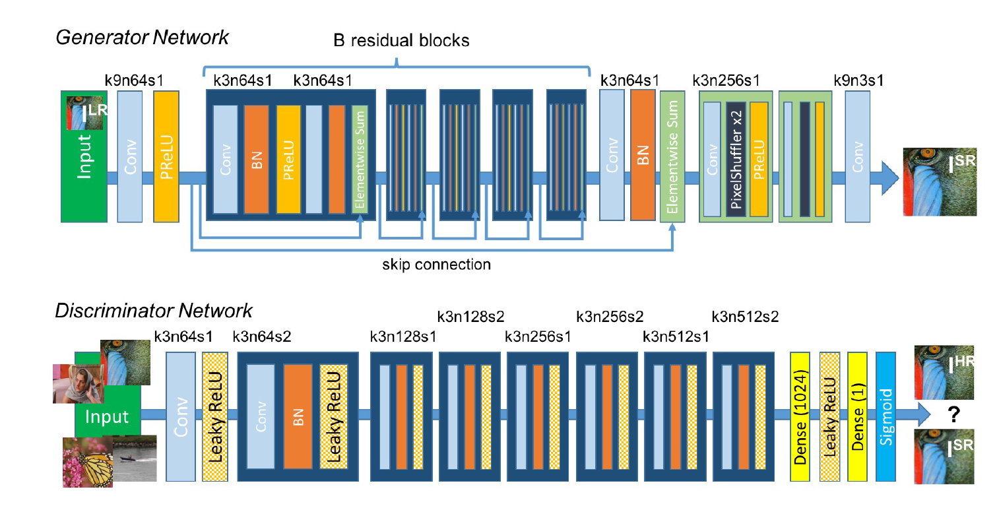

Figure-5: Architecture of Generator and Discriminator Network with corresponding kernel size (k), number of feature maps (n) and stride (s) indicated for each convolutional layer.

Source: arXiv, 1609.04802, 2017

**B08086_04_15.png**

Now it’s time to deep dive into the code with Tensorflow and generate high resolution images using LFW facial dataset.

The generator network is first built as a single deconvolution layer with 3×3 kernels and 64 feature maps followed by relu as activation function. Then there are 5 residual blocks with identical layout of each block having two convolutional layers followed by batch-normalization and relu. Finally, the resolution of the input image is increased by two trained pixel-shuffle layers.

def generator(self, x, is_training, reuse):

with tf.variable_scope('generator', reuse=reuse):

with tf.variable_scope('deconv1'):

x = deconv_layer(

x, [3, 3, 64, 3], [self.batch_size, 24, 24, 64], 1)

x = tf.nn.relu(x)

shortcut = x

# 5 Residual block with identical layout of deconvolution layers having batch norm and relu as activation function.

for i in range(5):

mid = x

with tf.variable_scope('block{}a'.format(i+1)):

x = deconv_layer(x, [3, 3, 64, 64], [self.batch_size, 24,

24, 64], 1)

x = batch_normalize(x, is_training)

x = tf.nn.relu(x)

# 2 deconvolution layers having pixel-suffle and relu as activation function.

with tf.variable_scope('deconv3'):

x = deconv_layer(x, [3, 3, 256, 64], [self.batch_size, 24,

24, 256], 1)

x = pixel_shuffle_layer(x, 2, 64) # n_split = 256 / 2 ** 2

x = tf.nn.relu(x)

with tf.variable_scope('deconv4'):

x = deconv_layer(x, [3, 3, 64, 64], [self.batch_size, 48,

48, 64], 1)

x = pixel_shuffle_layer(x, 2, 16)

x = tf.nn.relu(x)

. . . . . . . . [code omitted for clarity]

return x

The deconvolution layer function is defined with tensorflow conv2d_transpose method with Xavier initialization as shown below.

def deconv_layer(x, filter_shape, output_shape, stride, trainable=True):

filter_ = tf.get_variable(

name='weight',

shape=filter_shape,

dtype=tf.float32,

initializer=tf.contrib.layers.xavier_initializer(),

trainable=trainable)

return tf.nn.conv2d_transpose(

value=x,

filter=filter_,

output_shape=output_shape,

strides=[1, stride, stride, 1])

The discriminator network consists of eight convolutional layers having 3 × 3 filter kernels that gets increased by a factor of 2 from 64 to 512 kernels. The resulting 512 feature maps is flattened and goes through two dense fully connected layers and followed by a final softmax layer to obtain a classification probability for generated image sample.

def discriminator(self, x, is_training, reuse):

with tf.variable_scope('discriminator', reuse=reuse):

with tf.variable_scope('conv1'):

x = conv_layer(x, [3, 3, 3, 64], 1)

x = lrelu(x)

with tf.variable_scope('conv2'):

x = conv_layer(x, [3, 3, 64, 64], 2)

x = lrelu(x)

x = batch_normalize(x, is_training)

. . . . . . [code omitted for clarity]

x = flatten_layer(x)

with tf.variable_scope('fc'):

x = full_connection_layer(x, 1024)

x = lrelu(x)

with tf.variable_scope('softmax'):

x = full_connection_layer(x, 1)

return x

The network uses LeakyReLU (with α = 0.2) as activation function with the convolutional layer.

def lrelu(x, trainbable=None):

alpha = 0.2

return tf.maximum(alpha * x, x)

The convolution layer function is defined with tensorflow conv2d method with Xavier initialization as shown below.

def conv_layer(x, filter_shape, stride, trainable=True):

filter_ = tf.get_variable(

name='weight',

shape=filter_shape,

dtype=tf.float32,

initializer=tf.contrib.layers.xavier_initializer(),

trainable=trainable)

return tf.nn.conv2d(

input=x,

filter=filter_,

strides=[1, stride, stride, 1],

padding='SAME')

Please note that the code implementation uses the least squares loss function (to avoid vanishing gradient problem) for the discriminator, instead of the sigmoid cross entropy loss function as proposed in the original paper of SRGAN (*arXiv, 1609.04802, 2017*).

def inference_adversarial_loss(real_output, fake_output):

alpha = 1e-5

g_loss = tf.reduce_mean(

tf.nn.l2_loss(fake_output - tf.ones_like(fake_output)))

d_loss_real = tf.reduce_mean(

tf.nn.l2_loss(real_output - tf.ones_like(true_output)))

d_loss_fake = tf.reduce_mean(

tf.nn.l2_loss(fake_output + tf.zeros_like(fake_output)))

d_loss = d_loss_real + d_loss_fake

return (g_loss * alpha, d_loss * alpha)

generator_loss, discriminator_loss = (

inference_adversarial_loss(true_output, fake_output))

More information about Least Square GAN can be found at:

(https://arxiv.org/abs/1611.04076)

Code directory structure for running the SRGAN is shown below:

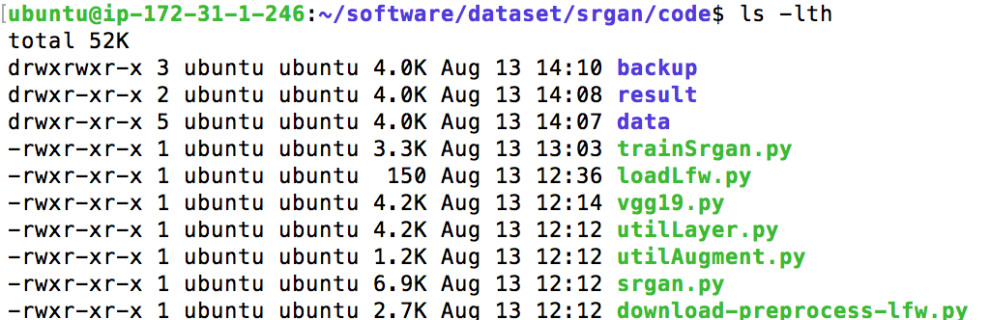

**B08086_04_16.png**

First let us download LFW facial dataset and do some preprocessing (frontal face detection and splitting dataset as train and test) and store the dataset under data/ directory.

python download-preprocess-lfw.py



**B08086_04_17.png**

Next download the pre-trained VGG19 model from the link below, extract it and save it under backup/ directory.

<https://drive.google.com/open?id=0B-s6ok7B0V9vcXNfSzdjZ0lCc0k>

Next execute the trainSrgan.py file to start the SRGAN operation using vgg19 model.

python trainSrgan.py

Once the training is going on the generator network will start generating super resolution images in the result directory. Some of the sample images from the result/ directory are shown below:

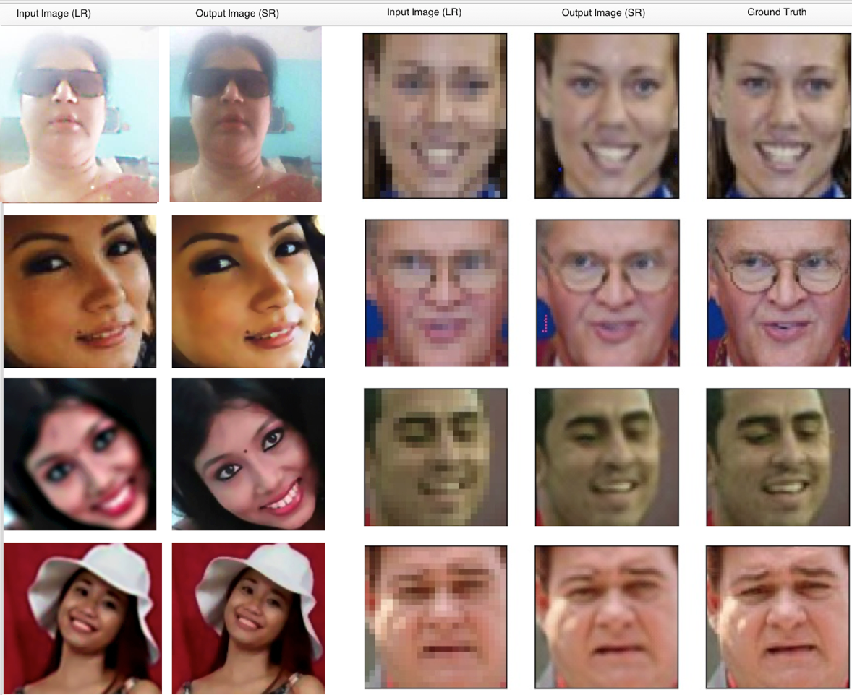

**B08086_04_18.png**

## Generate artistic hallucinated images using Deep Dream

Deep Dream algorithm is a modified neural network that has capability of producing impressive surrealistic, dream-like hallucinogenic appearances by changing the image in the direction of training data. It uses the backpropagation to change the image instead of changing weights through the network.

Broadly the algorithm can be summarized in the following steps:

1. Select a layer of the network and a filter that you feel interesting
2. Then compute the activations of the image up to that layer
3. Back-propagate the activations of the filter back to the input image
4. Multiply the gradients with learning rate and add them to the input image
5. Repeat step 2 to 4 until you are satisfied with the result

Applying the algorithm iteratively on the output and applying some zooming after each iteration, helps the network to generate an endless stream of new impressions by exploring the set of things the it knows about.

Let deep dive into the code to generate a hallucinogenic dreamy image. We will apply the following settings to the various layer of the pre-trained **vgg16** model available in keras. Note instead of using pre-trained we can apply this setting to a fresh neural network architecture of your choice as well.

settings_preset = {

'dreamy': {

'features': {

'block5_conv1': 0.05,

'block5_conv2': 0.02

},

'continuity': 0.1,

'dream_l2': 0.02,

'jitter': 0

}

}

settings = settings_preset['dreamy']

This utility function basically loads, resize and format images to appropriate tensors format.

def preprocess_image(image_path):

img = load_img(image_path, target_size=(img_height, img_width))

img = img_to_array(img)

img = np.expand_dims(img, axis=0)

img = vgg16.preprocess_input(img)

return img

Then we calculate the continuity loss to give image a local coherence and avoid messy blurs that looks like a variant of the total variation loss discussed in the paper (http://www.robots.ox.ac.uk/~vedaldi/assets/pubs/mahendran15understanding.pdf)

def continuity_loss(x):

assert K.ndim(x) == 4

a = K.square(x[:, :img_height-1, :img_width-1, :] -

x[:, 1:, :img_width-1, :])

b = K.square(x[:, :img_height-1, :img_width-1, :] -

x[:, :img_height-1, 1:, :])

# (a+b) is the squared spatial gradient, 1.25 is a hyperparameter # that should be >1.0 as discussed in the aforementioned paper

return K.sum(K.pow(a+b, 1.25))

Next, we will load the vgg16 model with pretrained weights.

model = vgg16.VGG16(input_tensor=dream, weights='imagenet', include_top=False)

After that we will add the L2 norm of the features of a layer to the loss and then add continuity loss to give the image local coherence followed by adding again L2 norm to loss in-order to prevents pixels from taking very high values and then compute the gradients of the dream with respect to the loss.

loss += settings['continuity'] * continuity_loss(dream) / np.prod(img_size)

loss += settings['dream_l2'] * K.sum(K.square(dream)) / np.prod(img_size)

grads = K.gradients(loss, dream)

Finally, we will add a random jitter to the input image and run the L-BFGS optimizer over the pixels of the generated image to minimize the loss.

random_jitter = (settings['jitter']*2) * (np.random.random(img_size)-0.5)

x += random_jitter

# run L-BFGS

x, min_val, info = fmin_l_bfgs_b(evaluator.loss, x.flatten(),

fprime=evaluator.grads, maxfun=7)

At the end, we will decode the dream and save it in output image file.

x = x.reshape(img_size)

x -= random_jitter

img = deprocess_image(np.copy(x))

fn = result_prefix + '_at_iteration_%d.png' % i

imsave(fn, img)

The dreamy output generated just after 5 iterations is shown below:

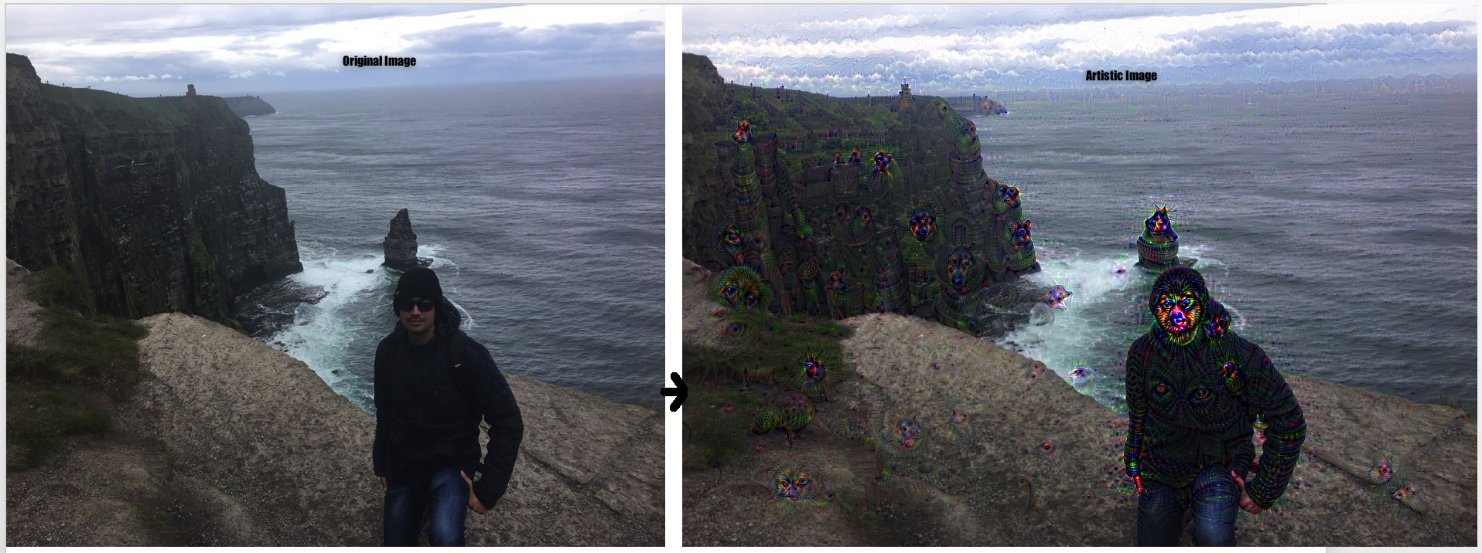

Figure-6: Left showing the original input image and Right showing the dreamy artistic image created by deep dream

**B08086_04_19.png**

## Generate handwritten digits with VAE using Tensorflow

The **Variational Autoencoder**or **VAE** nicely synthesizes unsupervised learning with variational Bayesian methods into a sleek package. It applies a probabilistic turn on the basic autoencoder approach by treating inputs, hidden representations, and reconstructed outputs as probabilistic random variables within a directed graphical model.

From [Bayesian](https://xkcd.com/1236/) perspective, the encoder becomes a variational inference network, that maps the observed inputs to posterior distributions over latent space, and the decoder becomes a generative *network*, that maps the arbitrary latent coordinates back to distributions over the original data space.

## Real world Analogy of VAE

Let say we want to generate a data (an animal) and a good way of doing is to first to decide, what kind of data we want to generate, before actually generating the data. So, we must imagine some criteria about representing the animal- like it should have 4 legs and be able to swim. One we have those criteria, we can then generate the animal by sampling from animal kingdom. Our imagination criteria are analogous to **latent variables**. Deciding the latent variable in first place, helps to describe the data well, otherwise it is like generating data blindly.

The basic idea of VAE is to infer p(z) using p(z|x). Let’s now expand with some mathematical notation-

x: represent the data (i.e. animal) we want to generate.

z: represent the latent variable (i.e. our imagination).

p(x): represent the distribution of data (i.e. animal kingdom).

p(z): represent normal probability distribution of latent variable (i.e. source of imagination – our brain).

p(x|z): probability distribution of generating data given latent variable (i.e. turn imagination into realistic animal).

As per the analogous example, we want to restrict our imagination only on animal kingdom domain, so that we shouldn’t imagine about things like root, leaf, money, glass, GPU, refrigerator, carpet, … as it’s very unlikely that those things have anything in common with the animal kingdom.

The loss function of the variational autoencoder is basically the negative log-likelihood with a regularizer as shown below.



**B08086_04_20.png**

The first term is the expected negative log-likelihood or reconstruction loss of the i-th data point where the expectation is calculated with respect to the encoder’s distribution over the representations. This term helps the decoder to reconstruct the data well and incur large cost if it fails to do so. The second term represents Kullback-Leibler divergence between encoder distribution q(z|x) and p(z) and act as a regularizer that add a penalty to the loss when encoder’s output representation z differs from normal distribution.

Now let’s deep dive into the code for generating handwritten digits from mnist dataset with VAE using Tensorflow. First let us create the encoder network Q(z|X) with single hidden layer, that will take X as input and output μ(X) and Σ(X) as part of Gaussian distribution.

X = tf.placeholder(tf.float32, shape=[None, X_dim])

z = tf.placeholder(tf.float32, shape=[None, z_dim])

Q_W1 = tf.Variable(xavier_init([X_dim, h_dim]))

Q_b1 = tf.Variable(tf.zeros(shape=[h_dim]))

Q_W2_mu = tf.Variable(xavier_init([h_dim, z_dim]))

Q_b2_mu = tf.Variable(tf.zeros(shape=[z_dim]))

Q_W2_sigma = tf.Variable(xavier_init([h_dim, z_dim]))

Q_b2_sigma = tf.Variable(tf.zeros(shape=[z_dim]))

def Q(X):

h = tf.nn.relu(tf.matmul(X, Q_W1) + Q_b1)

z_mu = tf.matmul(h, Q_W2_mu) + Q_b2_mu

z_logvar = tf.matmul(h, Q_W2_sigma) + Q_b2_sigma

return z_mu, z_logvar

Now we create the decoder network P(X|z):

P_W1 = tf.Variable(xavier_init([z_dim, h_dim]))

P_b1 = tf.Variable(tf.zeros(shape=[h_dim]))

P_W2 = tf.Variable(xavier_init([h_dim, X_dim]))

P_b2 = tf.Variable(tf.zeros(shape=[X_dim]))

def P(z):

h = tf.nn.relu(tf.matmul(z, P_W1) + P_b1)

logits = tf.matmul(h, P_W2) + P_b2

prob = tf.nn.sigmoid(logits)

return prob, logits

Then we calculate the reconstruction loss and kullback leivar divergence loss and sum them up to get the total loss of the vae network.

recon_loss = tf.reduce_sum(tf.nn.sigmoid_cross_entropy_with_logits(logits=logits, labels=X), 1)

kl_loss = 0.5 * tf.reduce_sum(tf.exp(z_logvar) + z_mu**2 - 1. - z_logvar, 1)

# VAE loss

vae_loss = tf.reduce_mean(recon_loss + kl_loss)

And then uses adam optimizer to minimize the loss.

solver = tf.train.AdamOptimizer().minimize(vae_loss)

Run the file (VAE.py or VAE.ipynb) to start variational auto encoder operation on mnist dataset and the images will be generated in the output folder. The sample handwritten digit images generated after 10,000 iterations:

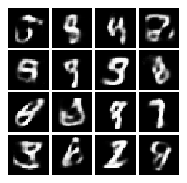

**B08086_04_21.png**

## Comparison of two generative models- GAN and VAE

## Although both are very exciting approaches of generative model and has helped researcher to make inroads in the unsupervised domain along with generating capability. But these two models differ in the way of how they are trained. GAN is rooted in game theory, with an objective to find the Nash Equilibrium between discriminator network and generator network. Whereas, VAE is rooted in bayesian inference, i.e. it tries to model the probability distribution of underlying data, in order to sample new data from that distribution.

VAEs has a clear known way of evaluating the quality of the model (like log-likelihood, either estimated by importance sampling or lower-bounded) compare to GANs, but it often generates blur images compared to GANs due to the effect of injected noise, imperfect reconstruction and standard decoder.

## Summary

Transfer Learning address the problem of dealing with small data effectively without re-inventing the training wheel from scratch. You have learned to extract and transfer features from pre-trained model and apply it to your own problem domain. Also, you have master to train and run deeper models over large scale distributed system using Spark and its related components. Then, you have generated realistic high-resolution images leveraging the power of transfer learning within SRGAN. Also, you have master the concepts other generative model approaches like VAE and Deep dream for artistic image generation. In the last chapter, we will shift our focus from training deep models or generative models and learn various approaches of deploying your deep learning based applications in production